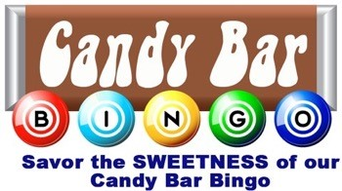

Join us Friday February 21, 2020 for our annual candy bar bingo in FP MPR, from 6pm to 8pm.
We will be playing ‘Hearts’ themed bingo. Feel free to decorate yourself in anything hearts !! Come and play bingo for chances to win candy.
Hope to see you there!!
Event is being sponsored by the PTO of LEH.

